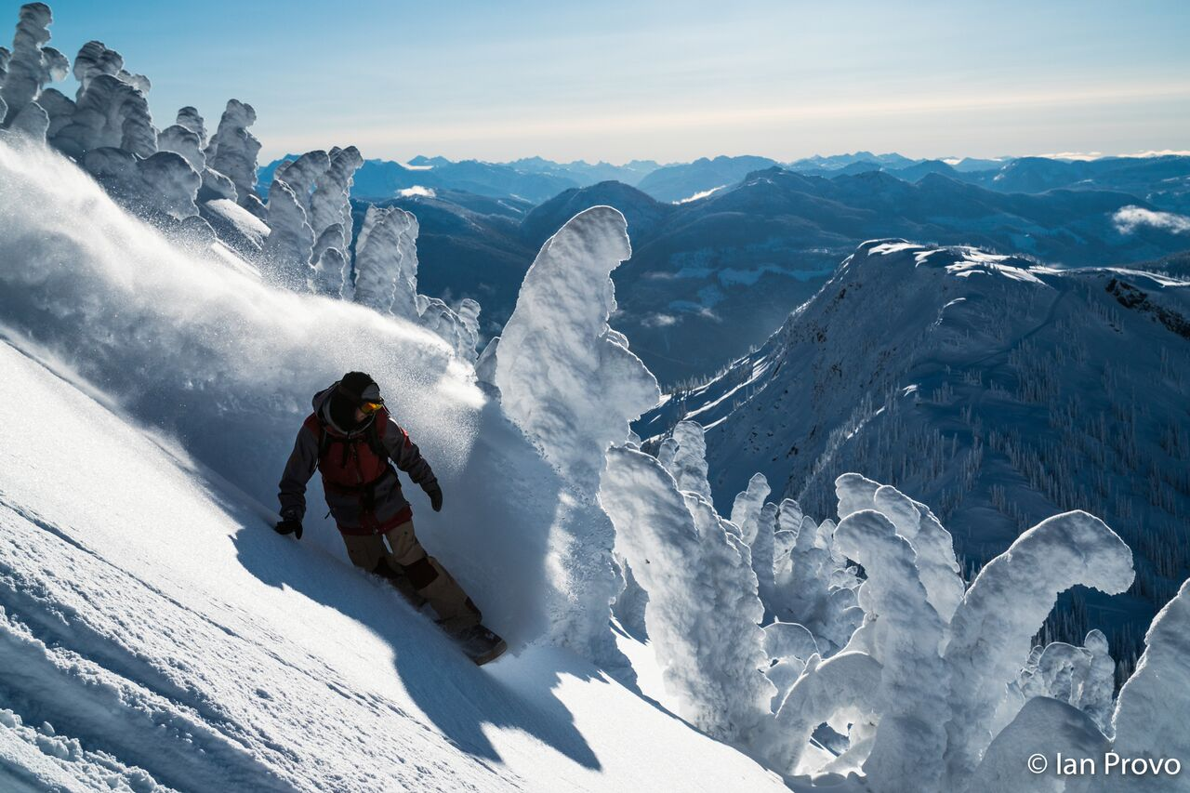
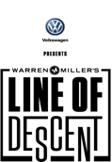
Presented by Lansing’s Jug and Mug Ski Club
In Partnership With The
Okemos High School Ski Team
Friday, December 1, 2017
Okemos High School
2800 Jolly Road, Okemos, MI 48864

Ticket Purchase for Warren Miller’s Extreme Ski Movie, Line of Descent, December 1, 2017.
Send your payment with this completed form to Jug & Mug Ski Club, PO Box 13153, Lansing, MI 48901. Make check payable to Jug & Mug Ski Club. Payment must be received by November 30, 2017. Cost is $10.00 each.
Name: | Mailing Address:
E:Mail: | Phone: | No. of Tickets @ $10 each:
Your Signature: |  | Total Amount Included: $
6:00 P.M. Doors Open
Visit the Vendor Tables and Okemos High School Ski Team Table.

7:00 P.M. Movie Begins

.

YOUR TICKET INCLUDES:
- One-year subscription to SKI Magazine.
- Door prizes and discount coupons from Shanty Creek, Boyne Resorts, Crystal Mountain, Mt. Brighton, Caberfae, Summit Sports and other ski areas and suppliers.

Tickets can be purchased at the following locations:
Lansing; Campus Corner, Moose Jaw, or Summit Sports, Grand River, E. Lansing.
Also from Club members and at the General Meeting November 17 at Tony M’s.
OR PAYPAL on jugandmug.org website

Please visit the jugandmug.org website and Facebook page for details and
Warren Miller Entertainment @ http://www.skinet.com/warrenmiller/
Call (517) 663.1854 for more information and to order tickets.

Tickets Are:
$10 in Advance
$11 PayPal
$15 at the Door

